**TELONE CENTRE FOR LEARNING**

**TECHNICAL DEPARTMENT**



**Environmental Management Agency Monitoring System for Greenhouse Gases**

**BY WAYNE TSONHA (T2276268X)**

**SUPERVISOR: MR. F. SUWALI**

*A research project submitted in partial fulfilment of the requirements for Diploma in Telecommunications Engineering, August 2025*

**Chapter 1: INTRODUCTION**

**1.1 Introduction**

In the modern world we are living today we are facing climate change and the rise of deaths from greenhouse gases that we fail to see and monitor as a result we face catastrophic changes in emissions and levels. Environmental management is becoming increasingly critical as greenhouse gas emissions continue to impact climate change and air quality worldwide. Traditional methods of monitoring greenhouse gases rely on manual sampling and periodic assessments, which often result in delayed data, inaccuracies, and inefficiencies in addressing environmental issues. With the advancement of Internet of Things (IoT) technology, real-time monitoring systems offer a transformative solution that provides timely, precise, and automated measurement of greenhouse gases. By leveraging IoT sensors, environmental agencies can shift from outdated monitoring techniques to a more dynamic and interconnected system that continuously tracks air pollution levels, detects harmful emissions, and supports data-driven decision-making. This research aims to develop an

Environmental Management Monitoring System that enhances the ability to measure and analyse greenhouse gases efficiently, thereby enabling policymakers and environmental authorities to implement effective mitigation strategies.

**1.2 Background Information**

Traditional environmental monitoring methods rely on manual air sampling and labour-intensive field inspections, which often lead to delays in detecting pollution sources and the type of gases which are being emitted into the air. These operational methods lack real-time data collection, making it difficult for environmental management agencies to respond swiftly to emissions-related challenges and having mitigation measures to reduce pollution. Moreover, these systems may not provide comprehensive coverage, leaving gaps in data accuracy and to pinpoint the sources of Greenhouse Gases. IoT-based monitoring systems address these limitations by integrating sensors, accurate data reading algorithms, and automated alerts to deliver continuous greenhouse gas measurements. By implementing such a system, environmental agency can ensure timely responses, accurate pollution tracking, and transparent reporting. The shift from manual to IoT-driven environmental management

enhances data reliability while reducing operational costs, human intervention errors and actually having an integrated platform to share data.

**1.3 Problem Definition**

The current methods of monitoring Greenhouse gas emissions suffer from several inefficiencies that vary such that the Environmental Management Agency has challenges in monitoring Greenhouse gases in urban areas. There is delayed data collection which requires manual sampling and it does not provide real-time insight into emission levels and the geographical area of pollution.

**Aim**

This project aims to design and develop an IoT based Greenhouse gas monitoring system that can monitor and alert the in real-time with the use of robust communication.

**1.4 Objectives**

The primary objective of this project is to develop an IoT-based greenhouse gas monitoring system that provides real-time, accurate, and actionable data to help the Environmental Agency to efficiently manage emissions. The system is designed to replace traditional monitoring methods with a more automated and data-driven approach. To achieve this, the project will focus on the following objectives:

* To design and assemble IoT sensor nodes equipped with communication modules for real-time data acquisition and transmission to a central monitoring system.
* To develop and integrate appropriate IoT sensors capable of accurately measuring oxygen levels and greenhouse gases such as carbon dioxide (CO₂), methane (CH₄), and nitrogen oxides (NOₓ) to ensure precise environmental monitoring.
* To develop a comparative analysis of the system efficiency by evaluating the accuracy, speed, and cost-effectiveness of the IoT-based solution against traditional monitoring methods.

**1.5 Functionality**

The Environmental Management Monitoring System will integrate multiple IoT-based components to provide efficient, automated tracking of greenhouse gases. The key functionalities include:

* Sensor network integration: To have an integration of IoT sensors capable of detecting Carbon dioxide, methane, and other greenhouse gases deployed across multiple locations.
* Real-time data transmission: To have a system automatically sending collected data to central data base for instant analysis.
* Automated alerts and notifications: To have a system triggering immediate warnings when emission levels exceed predefined thresholds.
* Data display and reporting: To have a well presentable intuitive graphs and statistics for environmental agencies and policymakers.
* Centralized control panel: To have control and management of the system and real-time data collection.
* Historical data analysis: To have a long-term tracking to observe trends and predict pollution patterns.

**1.6 Justification**

The move towards an advanced environmental monitoring solution has grown as climate change concerns and it is a necessity as industrial emissions increase, the human population is experiencing a rise in airborne related illnesses that culminate to many deaths. IoT technology presents a highly effective alternative to traditional greenhouse gas measurement methods, which is offering enhanced accuracy that is use of automated sensors eliminate human error and ensure precise readings. There is timeliness which involve real-time data collection enables instant responses to pollution events. There is cost efficiency that is reduction in labour intensive monitoring which lowers operational expenses. Data transparency is also a significant factor in having an open access to environmental information for policy makers, researchers and the general public. The need for policies to strengthen and govern regulatory enforcement through reliable data readings. Investing in the environmental monitoring aligns with the global goal on climate action, sustainability good quality air, making it a crucial step towards an effective transformative in environmental management.

**1.8 Conclusion**

This chapter provided an introduction to the Environmental monitoring system for Greenhouse gases, giving the challenges in current greenhouse gas monitoring systems and the critical need for an advanced IoT-based solution. The importance of the project lies in its ability to combat emissions of greenhouse gases for an effective user friendly environment. The objectives of the project were outlined, including the development of a user friendly monitoring system that is both efficient and cost effective Greenhouse gas management. It is a matter of concern that they are limitations to be considered, such as the potential of technical issues and the need of connectivity problems.

In the upcoming chapter on the requirements engineering, they will be a detailed analysis of the technical architecture, system implementation needed for the greenhouse gas monitoring system. This will have to involve the gathering and documented user needs, and overall the completion of this chapter has laid the groundwork for the rest of the project, setting the stage for the development of a successful Greenhouse gas monitoring system.

**CHAPTER 2.0 REQUIREMENTS ENGINEERING**

**2.1 Introduction**

In this chapter, we will focus on the important phase of the requirement engineering, which is crucial for the successful development and deployment of the Greenhouse gas monitoring system. This chapter aims to identify and analyse the specific requirement necessary for designing a reliable, and user friendly monitoring system that meets the needs of a clean environment.

This system includes advanced sensors, communication modules and data analytic to provide a well detailed insight into greenhouse gas levels and location information is transmitted to the environmental management agency in real-time, that enable policy makers and other stakeholders to monitor emission sources as well as mitigation strategies.

Through a detailed requirement elicitation, analysis, specification and validation, this chapter aims to define the functional and non-functional requirements of the Greenhouse gas monitoring system. By understanding the needs of all stakeholders the aim is to develop comprehensive set of requirements that will guide the development process.

In the following sections of this chapter, we will have to explore various aspects of requirements engineering, including the business value of the system, methodologies for information gathering, tangible and intangible benefits, feasibility study and the risk analysis of the project. The applications of the best practices in requirements engineering, we aim to create a solid foundation for successful development and deployment of the Greenhouse gas monitoring system.

**2.2 Literature Review**

In the recent years, there has been advancements in smart monitoring technologies and this has led to the development and improved capacity to track emissions of the Greenhouse gases real-time data to the Environmental Management Agency.

One of the key requirements for an effective Greenhouse gas monitoring system is the ability to detect emission sources, quantity Greenhouse gases, and predict future trends. The other important requirement for the Greenhouse gas monitoring system is to collect and transmit data to the relevant stakeholders. This allows for real-time monitoring of the emissions and the system should be able to give analysis of the data collected and provide better regulatory compliance and proactive mitigation strategies.Anuj Kumar et al. [1] developed a wireless environment monitoring system to monitor the greenhouse gases such as Carbon Monoxide(CO), Carbon Dioxide (CO2) and Oxygen (O2) present in the atmosphere along with the environmental parameter.

Overall requirements engineering is a crucial aspect of the development of a Greenhouse monitoring system. Thereby with the understanding of key requirements such as real-time tracking, communication, and data analytics, we can design a system that meets the needs of the Environmental Management Agency offering a smarter and more efficient approach to greenhouse gas management in the environment.

**2.3 Business Value**

The Greenhouse gas monitoring system brings significant business value to the environmental agency, industrial stakeholders and the society. It incorporates precise, real-time data on greenhouse gas emissions. The system facilitates a good environmental regulatory and it enables industries to meet national and international standards.

The system offers key benefits as it supports early detection of emission spikes, allowing timely mitigation measures that can reduce environmental impact and health risks. In addition, the system enhances data driven decision making, emission reduction strategies and supports climate change mitigation efforts. It also assists the industries in the identification of inefficient processes and promote sustainable practices.

Moreover, the Greenhouse gas monitoring system is a technological innovation that brings change in the Environment Management in supporting policy development, and contributing to global efforts to combat climate change.

**2.4 Information Gathering Methodologies**

Information gathering for the Greenhouse gas monitoring system will involve various methodologies to accurately capture system requirements are correctly identified and documented.

1. Stakeholder interviews: We conducted discussions with environmental regulators, industry representatives and community to understand their perspectives on the system requirements and gather insights into the needs and constraints.
2. Environmental Site Observation: We observed on the site the industrial facilities and the emissions sources to have the assessment of the current monitoring practices and identify gaps
3. Surveys and Questionnaires: We had to have a distribution of questions on the fact finding among stakeholders to gather quantitative data on the desired functionalities and usability preferences.

By using the methodologies, our aim is to accurately capture and document the requirements for the greenhouse gas monitoring system. The methodologies ensure a comprehensive understanding of the system needs that align technical abilities and stakeholder expectations.

**2.5 Tangible Benefits**

1. Enhanced Monitoring Accuracy-The precise sensors and wireless data transmission provide reliable emission data.
2. Regulatory Compliance-It facilitates adherence to environmental laws and reporting standards.
3. Operational Efficiency-It automates data collection and analysis, reducing manual effort and errors.
4. Cost Savings- It minimizes the need for manual inspections and physical sampling there by reducing the need for field trips.

**2.6 Intangible Benefits**

1. Environmental Awareness-There is increased transparency that encourages industries to adopt greener practices that reduce emissions of greenhouse gases.
2. Public Trust-It demonstrates the commitment to environmental responsibility as well as the role every citizen should play.
3. Community Health-There is early detection of high emission levels helps mitigate health risks that come with greenhouse gases.
4. Stakeholder Engagement-It promotes collaboration among government, industry, and communities for sustainable development and helps to have a common goal to achieve in the environmental management

**2.7 Feasibility Study**

The Greenhouse gas monitoring system is designed to change the way we monitor the environment thus enabling continuous and monitoring of the gas levels. The feasibility study aims to assess technical, economical and operational aspects.

**2.7.1 Technical Feasibility**

The Greenhouse gas monitoring system equipped with sensors and data transmission modules is highly feasible due to the advancement in the IoT technology and telecommunication infrastructure. This system will utilize sensors, microcontrollers and communication modules to detect multiple gases with high precision.

Small and affordable sensors make it possible to monitor various gases such as carbon dioxide, methane and nitrogen. The Greenhouse gas monitoring system ensures that they is secure data storage and accessibility that many stakeholders may use the data in their researches.

**2.7.2 Economic Feasibility**

The economic feasibility of a new system is crucial in the environmental management where operators may be costly in data collection. The initial advent of a new system needs an investment in infrastructure. The Greenhouse gas monitoring system offers several benefits that have an impact on the environment.

Firstly, the system reduces the need for in-person environmental field assessments that is saving time and money as well as regulatory compliance and inspection cost. Real-time data collection provides the relevant stakeholders with potential funding sources that include environmental grants and corporate sponsorship to mitigate emission spikes through environmental governance.

In conclusion the Greenhouse gas monitoring system offers several benefits that can positively impact the economic feasibility of the environment by reducing the need for in person visits to the sites, facilitating early detection of the health related issues and provide valuable data insights to the reduction of dangerous gases in the environment.

**2.7.3 Operational feasibility**

Operational feasibility refers to the initial part that the proposed monitoring system can be implemented with a relevant organisational structure and resources. In the Greenhouse monitoring system several factors must be taken into consideration to determine its operational feasibility.

The factor to consider is the availability infrastructure to deploy the system, which include reliable communications and robust internet connectivity for access by other stakeholders. On the data collected by the monitoring system is to be transmitted to the environmental agency and they must be adherence to legal standards regarding data privacy and management. This may require implementation of encryption measures and establishing protocols for data storage and transmission.

Moreover, the operational feasibility of the Greenhouse gas monitoring system will depend on the organisation ability to invest in necessary infrastructure collaboration with industries and staff training programmes. In addressing the factors, the system with a successful implementation and adoption.

**2.7.4 Work Plan**

Here is a proposed work plan for the key activities involved in this project:

**2.8 Risk Analysis**

**a) Data Security Risks**

* + Risk: Unauthorized access to sensitive emission data.
  + Impact: Data breaches, loss of stakeholder trust.
  + Mitigation: Implement encryption, secure authentication, and regular security audits.

**b) Sensor Reliability Risks**

* + Risk: Sensor failure or drift leading to inaccurate data.
  + Impact: Misreporting, non-compliance.
  + Mitigation: Regular calibration, redundancy, and maintenance schedules.

**c) Interoperability Risks**

* + Risk: Compatibility issues with existing environmental databases.
  + Impact: Data integration failures.
  + Mitigation: Use standardized protocols and APIs.

**d) Regulatory Risks**

* + Risk: Changes in environmental laws or standards.
  + Impact: System obsolescence or non-compliance.
  + Mitigation: Continuous monitoring of legal updates, adaptable system design.

**e) Network Security Risks**

* + Risk: Cyberattacks on data transmission channels.
  + Impact: Data tampering or loss.
  + Mitigation: Firewalls, intrusion detection, and secure communication protocols.

**f) Ethical and Privacy Risks**

* + Risk: Unauthorized tracking of emission sources or data misuse.
  + Impact: Legal penalties and reputational damage.
  + Mitigation: Transparency, clear data governance policies, and stakeholder consent

By addressing these key risks through planning, robust security measures, and continuous monitoring, the Greenhouse gas monitoring system can successfully mitigate potential threats and ensure the reliable, secure and effective environmental monitoring.

**2.9 Summary**

Chapter Two of the project, focuses on requirements engineering for the Greenhouse gas monitoring system and provides a comprehensive overview of the various aspects that need to be considered in the development of the system. It discussed importance of understanding stakeholder needs through various methodologies and highlighted the systems potential benefits both tangible and intangible benefits. The chapter also discusses the business value of the system, highlighting the potential benefits that it can bring to different stakeholders were they are reduction in costs and emissions of dangerous gases to the environment. Information gathering methodologies are explored, including interviews with stakeholders and surveys to gather feedback on the system requirements on the implementation of the project.

A feasible study is conducted to determine the technical, economic and operational feasibility of the system, while a risk analysis is performed to identify potential risks and mitigation strategies. Establishing a comprehensive set of requirements ensures that the system will effectively support environmental monitoring, policy enforcement and climate change mitigation. Overall, this chapter provides a thorough overview of the requirements engineering process for the Greenhouse gas monitoring system, setting the stage for the development and implementation of the system.

**CHAPTER 3: SYSTEM/ALGORITHM ANALYSIS**

**3.1 Introduction**

In this chapter, there will be an in-depth analysis of the Environmental Management Agency Monitoring System for Greenhouse Gases. This system includes advanced sensors, communication modules, and data analytics to provide accurate data in real-time for the monitoring of Greenhouse emissions. The goal of this system is to have a robust and effective monitor system which enables authorities to monitor and implement measures.

We will explore and discuss the systems components from the hardware and software used for data analytics and interpretation. The integration of Internet of Things such as sensors play a crucial role in the systems functionality and transmission communication protocols that enable the accurate access of remote nodes. It will have algorithms for data processing and analysis, which includes predictive modelling and system alerts to notify when emission levels exceed certain levels.

Overall, this chapter will explore and provide an analysis of the Greenhouse Gas Monitoring system examining its components, functionality and performance to ensure a robust and effective solution for Environmental Management.

**3.2 Analysis of Existing Monitoring System**

The current Greenhouse gas monitoring system often involves periodic manual sampling and laboratory analysis. This method is not only time consuming but also prone significant delays in data availability. The method whilst it uses manual sampling while providing some data, are the consuming and are resource intensive in acquiring data. This leads to reactive Environmental Management other than proactive thus making it difficult to identify immediate spikes in emission and to assess the impact of mitigation strategies.

To address these limitations, the Greenhouse gas monitoring system can offer continuous, real-time data collection, enabling various authorities to respond promptly to Environmental and Health issues in case of emergencies. By analysing the existing system, it is a significant step forward that incorporating IoT technology in Greenhouse Gas Monitoring system will revolutionise the Environment for a clean one. The Greenhouse Gas Monitoring system offers enhanced efficiency, accuracy and real-time response, and provides a comprehensive solution that addresses the limitations of traditional monitoring methods.

**3.3 Data Analysis**

Data collected from the Greenhouse Gas monitoring system includes concentrations of Greenhouse Gases such as Carbon dioxide (CO2), Methane (CH4) and Carbon Monoxide (CO). The meteorology data such as temperature, oxygen and humidity can be collected since Greenhouse Gases also influence the climate change.

The data analysis involves real-time monitoring of stations and this data is transmitted to the EMA database for monitoring and analysis. The data analysis involves monitoring of Greenhouse Gas concentrations, tracking their distribution and identifying any warning signs of spikes. The system uses a predefined bound for acceptable emission levels and regulated limits. The Environmental Management Authority and other regulatory boards can request a comprehensive data report to keep track of emission trend and source.

**Data flow diagram**

Fig.1 Data Flow Diagram

**3.4 Overview of the proposed system**

The current Greenhouse Gas Monitoring system involves manual data collection by the EMA personnel. This traditional method is time consuming and prone to errors when it comes to data readings and laboratory analysis and it lacks a real-time monitoring capacity in the process to overcome the challenges the Greenhouse Gas Monitoring system can greatly improve the reduction of gases being emitted.

By integrating IoT based Greenhouse Gas sensors, it ensures accurate and real-time monitoring of gases in the defined location and the Environment at large allowing different stakeholders to efficiently use of gathered data in response to certain ailments and Environmental factors such as Climate Change. This ultimate solution overcomes the limitation of traditional monitoring methods and eventually change Greenhouse Gas emissions.

**3.4.1 Weakness of the current system**

1. Data Management: The continuous monitoring and transmission of data including vital gas levels and temperature, generates an enormous volume of data being send to the health care provider without an efficient data management and analysis system in place there could be processing backlogs and difficulty in extracting meaningful data.
2. Cost and Funding: The capital that is needed to deploy the system in various locations can be costly if we include the sensor network and data infrastructure. The cost of operating the system as well as maintenance can have a huge cost and thereby limiting the coverage of the system.
3. Data Security: The wireless data transmission to the environmental agency may pose a significant security threat. The lack of proper encryption protocols and secure data transfer is highly vulnerable to cyber threats that may lead to unauthorized access and data manipulation’
4. Training of the workforce: The system requires skilled labour in various fields that require a certain expertise in the relevant data structures. The lack of capacity to lead may result in underutilization of the system and the interpretation of data.

**3.4.2 Strengths of the current system**

1. Real-time monitoring: The system provides real-time data monitoring that is data streams that allow for the detection or rise in the emission spikes and enabling a quick response by the Environmental Management Agency.
2. Data accuracy: The system provides a reliable data collection which enabled by the utilization of a wide sensor network. It offers a precise visualization of emissions from the different locations as compared to the traditional manual sampling of data.
3. Cost effective: The introduction in the use of IoT based technology for Greenhouse Gas monitoring system can potentially reduce the time and money in conducting field trips and laboratory tests guarantees a well detailed and efficient data collected and reducing the time consuming and resource intensive task of manual data collection.
4. Increased Transparency: The system has the ability to provide the data collected to the different stakeholders like the public, industry research institutions and other organs fostering greater accountability in the well-being of the environment and a healthy nation.

**3.4.3 Evaluation of alternatives**

When evaluating alternatives for the analysis for the Greenhouse Gas monitoring system, several factors need to be considered. The reliability of the system, the efficiency of data transmission, accuracy of the data readings and security of the data.

One of the alternative is the use of Wi-Fi technology for transmission. It is widely used and common in many devices but it has limitations in terms of range and data transfer speeds if the connection has a redundant network.

Another alternative is the use of cellular networks. Whilst cellular networks are widely used it has a high bandwidth and wide spread coverage in urban and semi-urban areas making it useful for data transmission from the system.

Additionally, the security of transmitted data is crucial and it’s important that the secure system incorporates robust encryption and guard against unauthorized access or tempering.

Overall, the evaluation of alternatives for the Greenhouse Gas monitoring system should prioritise factors such as data transmission efficiency, cellular network, data security and data processing. We carefully consider and compare different alternatives, the system can be designed and implemented to effectively monitor the Greenhouse Gas levels.

**3.4.4 Requirements Analysis**

* The system must be incorporate robust data analytics algorithms capable of handling malfunctions and detecting anomalies.
* The system must have a reliable, configurable and automated alert system to notify when emission spike.
* The system must be scalable that is to have a number of sensors to measure different parameters for future regulatory needs.
* The system must have a design that is maintainable which allows for calibration and replacement of sensors and ensure easy diagnosis.
* The system must have a real-time capability of monitoring of Greenhouse Gases.

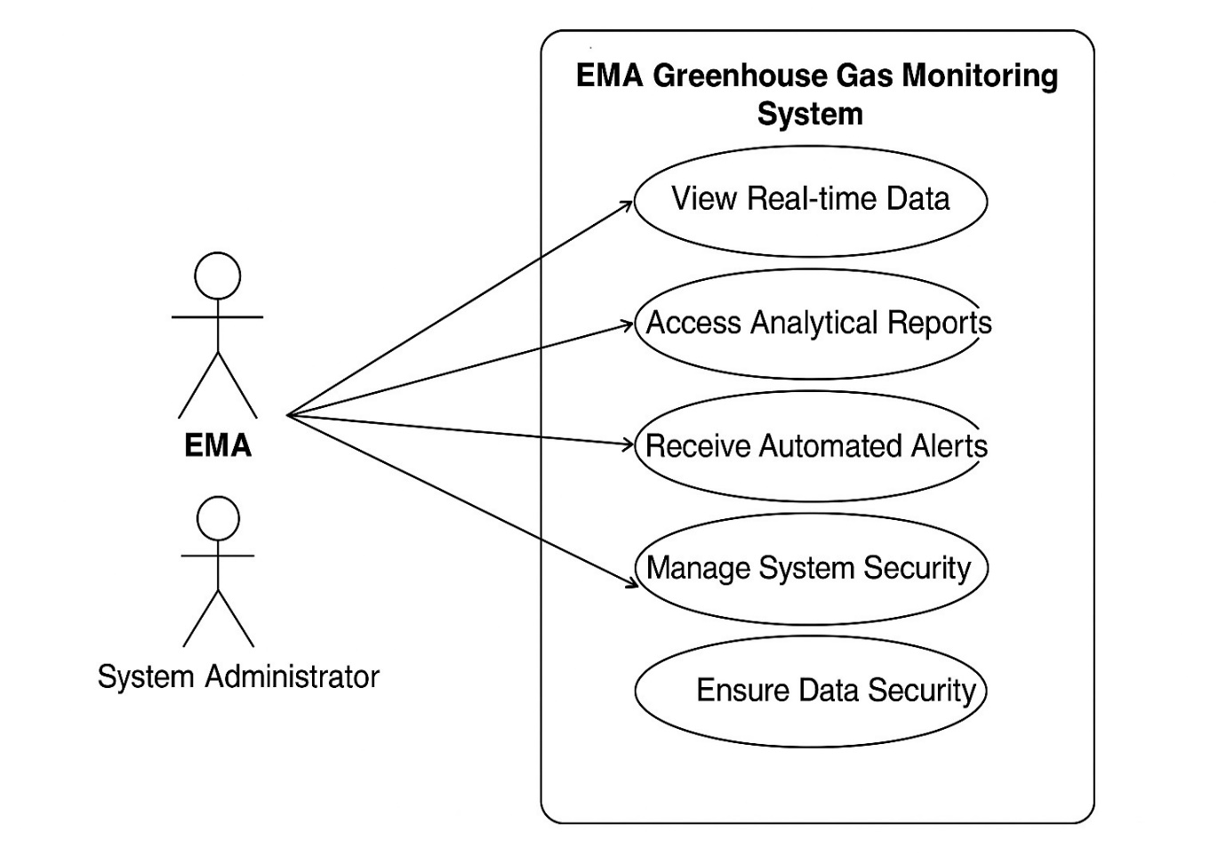

Fig 2. Case Diagram

**3.5 Summary**

In Chapter Three of the Project ‘Environmental Management Authority Greenhouse Gas Monitoring System’ we delve into analysis of the system model and algorithm used in the monitoring system. The chapter starts with an introduction, emphasizing and significance of a Greenhouse Monitoring system that integrates IoT technology and sensors for effective gas monitoring.

We analysed the existing system examining current technologies and systems in place for Greenhouse Gas Monitoring and identifying the strengths and weaknesses. This includes implementation of data flow diagrams to illustrate how data flows through the system.

The Overview of the proposed system outlines the key features and functionalities of the Greenhouse Gas monitoring, the innovative approach to monitoring system discussing the strength and weaknesses of the current system providing insight into areas that need potential enhancement. The evaluation of alternatives and establishing a clear set of system requirements that address the challenges we laid a solid foundation.

Overall, this chapter offers a well detailed analysis of the system model and algorithms used in the Greenhouse Gas monitoring system, laying the foundation for developing of the innovative monitoring solution.

**CHAPTER 4: PROTOTYPING/ SYSTEM DESIGN**

**4.1 Introduction**

The design and development of the Greenhouse Gas monitoring system is a crucial aspect of this project. The chapter focuses on discussing the various technological components and functionalities of the system, as well as the methodology that is used for the implementation of the project.

The Greenhouse Gas monitoring system allows for real time monitoring of the gases in the environment at a certain fixed location providing important information of dangerous gases are carbon dioxide, methane and other environmental parameters such as temperature and humidity etc.

The system comprises of monitoring and analysing Greenhouse Gases levels through advanced sensors which are integrated on a centralized system. The system prototype is developed using advanced sensors integrated on centralized system where it can be analysed and visualized. The design also include a user interface that ensures ease of use and awareness.

The development process covered various stages such as sensor and module selection, requirement analysis, data transmission protocol and the system design.

Overall, the chapter will provide a deep understanding into the design and development process of the Greenhouse Gas monitoring system, indicating the key features that make it a reliable and efficient environmental based system.

**4.2 System Inputs**

1. Gas Concentration levels
2. Environmental parameters such as temperature, humidity and oxygen
3. Sensor calibration and diagnostics
4. Measurement threshold values
5. Alarms and Alerts for gas spikes
6. User Interface for environmental officials

**4.3 System Process**

1. Data Collection: Sensors embedded in the system continuously monitor gas levels and other parameters such as temperature, humidity and oxygen in the environment.
2. Data Transmission: The data collected is transmitted using a wireless or wired connection through a communication module to a central monitoring unit.
3. Data Analysis: The system analyse the recorded sensor data for any spikes above the safe threshold and detect any abnormalities.
4. Alert System: An alert system that can be generated to alert the relevant authorities if they are spikes or abnormalities detected and this ensure appropriate action that need to be taken.
5. Data Storage: The recorded data from the sensors are stored in the local database for reporting and analysis.

In conclusion, the Greenhouse Gas monitoring system utilizes sensors, communication modules to provide real time monitoring and tracking of gas levels. The system process outlined in this chapter ensures efficient data gathering, transmission, analysis, alerting and storage as a way of improving environmental health and safety through diligent monitoring of emissions.

**4.4 System Output**

1. User friendly Interface

It’s an interactive UI showing real time metrics of the data recorded and the alert for the abnormalities detected in the environment. The data is easy to understand and visualisation offer a monitoring and analysis capability.

1. System Health Report

The reports of data to verify the functionality of the sensors and communication modules of the prototype if there is any failure of the system.

1. Alerts and Notifications

This system will be designed to show alerts based on different parameters as programmed by the relevant authorities for example if there is high concentration of gases which exceeds a certain limit, an alert will be triggered.

1. Gas level monitoring

The real-time gas concentration readings by the system with programmed alerts on the spikes threshold on the gas emissions.

1. Environmental parameters monitoring

It is the data recorded on the temperature, humidity and oxygen level for an overview of the environmental assessment.

**4.5 Architecture Design**

In this chapter, we will discuss the architecture design of the Greenhouse Gas monitoring system. The system is designed to monitor dangerous gas emissions and assess the level of the gas concentration. The design of the system give an insight on how data collected is transmitted to the relevant authorities.

1. Monitoring Devices

This include gas sensors that record the gas levels and some of the parameter sensors such as temperature, humidity and oxygen sensors. They are connected to a microcontroller that process the sensor data which can be either transmitted wirelessly or using a wired connection to a local data storage for analysis.

1. Communication Gateway

It is the one that collects and transmits data to the local data storage.It usually communicates using different protocols depending on the deployment.

1. Control Centre Interface

It is a central user interface dashboard which is a web based user interface that displays gas levels and alert logs. It supports multiple device connections for the interaction and control capabilities of the system.

1. User Interface Layer

It is a web based user interface where it shows real-time data and the analysis of the collected data. It has a feature which provides access to alerts and overall system configuration and diagnostics.

**4.6 Physical Design**

1. Alert System

The system is equipped with an alert system that notifies the authorities of any spikes of gas levels in the area. The alerts may be signified by LED indicators for visual alerts in the case of hazardous gas levels.

1. Communication Interface

The system has an integrated interface of a communication module that offer wireless and wired connection depending on the environment to be monitored in this case a WiFi and GSM module are to be used.

1. Microcontroller unit

The system has a central unit that is responsible for receiving, transmitting and processing the data from the sensors. It is responsible for running local diagnostics or calibration and also facilitates that sending or receiving of data which correlates with configurations that need to be made to the system.

1. Sensor module

The system has embedded sensors that involve gas sensors, temperature, oxygen and humidity sensors that are housed in a weather resistant compartment to protect the electronics compartment. The integration of the sensors offers a wide scope analysis of the environment and offers a detailed report all in one.

1. Power Supply

The system is powered by rechargeable batteries or a power adapter from the mains in case we are dealing in a place where the source of power is not available and a redundant power supply to the system comes into place.

1. Enclosure

The system has a enclosure that provide a mount to the sensors and the microcontroller as well as protect the electronic components of the system from different weather elements.

Overall, the physical design of the Greenhouse Gas monitoring system is a compact and reliable system which is capable to scale down the scope of monitoring gas levels and other parameters, thus having a single system doing the monitoring at a fixed location.

**4.7 Database Design**

Entities

1. EMA
2. Alerts
3. User(EMA official)
4. Sensor
5. Threshold settings

Alert table:

* Alert id
* Alert type
* Description
* Timestamp
* Message

Sensor Information

* Sensor id
* Sensor type
* Sensor Status
* Last Maintenance Date

Sensor Data

* Sensor id
* Gas level
* Temperature level
* Humidity level
* Oxygen level
* Timestamp

Threshold Settings

* Parameter
* Min value
* Max value
* Alert level

EMA

* User id
* Contact information
* Address
* Notification preferences

User Information

* User id
* Name
* Role
* Contact info
* Notification preferences

**Entity Relationship Diagram**

User----Sensor Data

User----Sensor Info

User----Alerts

EMA---Alerts

Overall, this database design allows for access, data readings and alerts. The system database is structured to support real-time data logging, querying and analysis in a comprehensive and organized system for the environmental management authority. It seeks to have the quality of a good environment in case of emergencies.

**4.8 Interface Design**

The interface design of the Greenhouse Gas monitoring system focuses on user-friendly experience for the authorities when analysing data collected. The user-interface design focuses on clarity and real time awareness to the Environmental authority thus offering reliable data. The interface design includes data visualisation that is a graphical representation of data that helps the user to understand the environmental patterns of gas levels and other parameters such as humidity, oxygen and temperature.

A web based interface that displays real time data readings from the sensors and the alert notifications for spikes in the recordings. The user interface use a message to give notifications for alerts and to offer a quick response to gas leaks or temperature spikes.

**4.9 Summary**

The Chapter Four of this project focuses on the design and implementation of the Greenhouse Gas monitoring system. The system inputs section explain the data source where we will gather the measurements that is the monitoring and tracking of gases and other parameters. The system output describes the alerts from the gas and temperature levels that come from the spikes that are measured using environmental sensors. The system integrates multiple sensors and utilizes IoT technologies for real time data transmission and monitoring.

The architecture design seeks to ensure that the system has robust monitoring and alert systems to govern in data storage as well in the transmission and the processing. The design process covers from sensor integration to user interface ensuring the system is scalable and user friendly for various aspects.

The database structure represents the outline of the database that will be used to store and manage the readings from the system, this may include design of tables, queries that will be used to retrieve and analyse data. The physical and interface design ensure efficient usability in the real world setting that is the hardware components used to implement the system design this include sensors and communication modules.

In conclusion Chapter Four provides an overview design and implementation of the Greenhouse Gas monitoring system that indicates the system capabilities in providing real time monitoring and enhance safety in environmental surveillance and regulations so as to help mitigate gas poisoning and climate change.

CHAPTER 5 : IMPLEMENTATION AND TESTING

5.1 INTRODUCTION

This chapter provides a comprehensive overview of the implementation and testing of the Environmental Management Agency Monitoring System for Greenhouse Gases. The system utilizes an ESP32 microcontroller installed in greenhouses and integrated with multiple sensors to measure methane, carbon dioxide, and nitrogen dioxide levels. Additional environmental parameters, such as temperature and humidity, are recorded using a DHT22 sensor. An LCD display is used to present real-time alerts, while a set of orange, and red LEDs, in combination with a buzzer, provide immediate visual and audible warnings for different hazard levels.

The system also incorporates a GSM module to send SMS notifications and an API-based Wi-Fi communication interface to transmit data from the ESP32 to the web-based dashboard. The backend system processes and visualizes the collected data, allowing EMA personnel and policy makers to monitor environmental conditions in real time and respond promptly to abnormal readings

.

5.2 CODING AND CONSTRUCTION

The system was developed using the Django framework for backend management and Tailwind CSS for user interface. The backend handles data from IoT sensor modules that measure gas concentrations and environmental parameters such as temperature, humidity. Role-based authentication was implemented to differentiate between EMA users and policy makers, providing each group with their dashboard.

The coding phase involved creating models to store sensor data, alerts, and system health reports. Views were designed to fetch and display real-time data along with historical trends. The frontend templates were developed with interactivity , allowing users to monitor gas levels and receive immediate alerts if dangerous spikes were detected.

The sensor hardware was programmed using C++. This code is responsible for interfacing directly with gas sensors, temperature sensors, and communication modules to gather and transmit data to the backend server.

5.3 TESTING

The following functional tests were conducted to verify the performance and reliability of the Environmental Management Agency Monitoring System for Greenhouse Gases:

* Wi-Fi Connection Test: Ensured the ESP32 successfully connected to the configured Wi-Fi network within 11 seconds for real-time data transmission to the web dashboard via API.

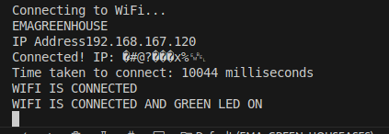  
Fig 5.3.1 – Wi-Fi connection log on serial monitor

* Sensor Accuracy Test: Verified that methane, carbon dioxide, nitrogen dioxide, temperature, and humidity readings from the sensors were recorderd and displayed on the dashboard.

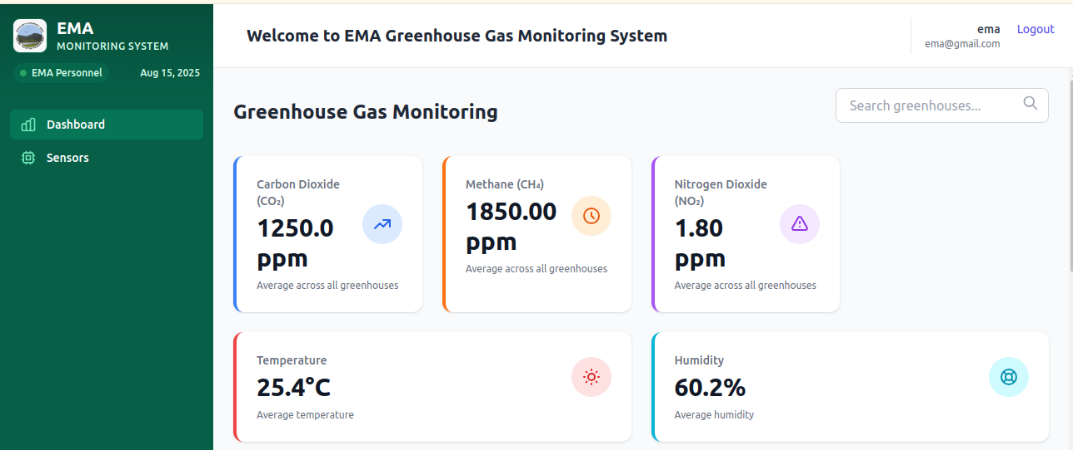  
Fig 5.3.2 – Real-time sensor readings on the web dashboard

* LCD Display Test: Confirmed that the LCD displayed real-time gas levels and alert messages correctly.
* LED and Buzzer Alert Test: Simulated threshold breaches to trigger orange, and red LED indicators, along with the buzzer, to ensure correct alert activation based on gas concentration levels.
* GSM SMS Notification Test: Checked that the GSM module successfully sent SMS alerts to predefined numbers when gas concentrations exceeded safe thresholds.
* Failover Scenario Test: Simulated loss of Wi-Fi connection and confirmed that local LCD alerts, LEDs, buzzer, and GSM notifications still functioned without internet connectivity.
* Security Login Test: Attempted to access the system dashboard using incorrect credentials to verify that unauthorized users are denied access. The system correctly displayed an error message and prevented access.
* 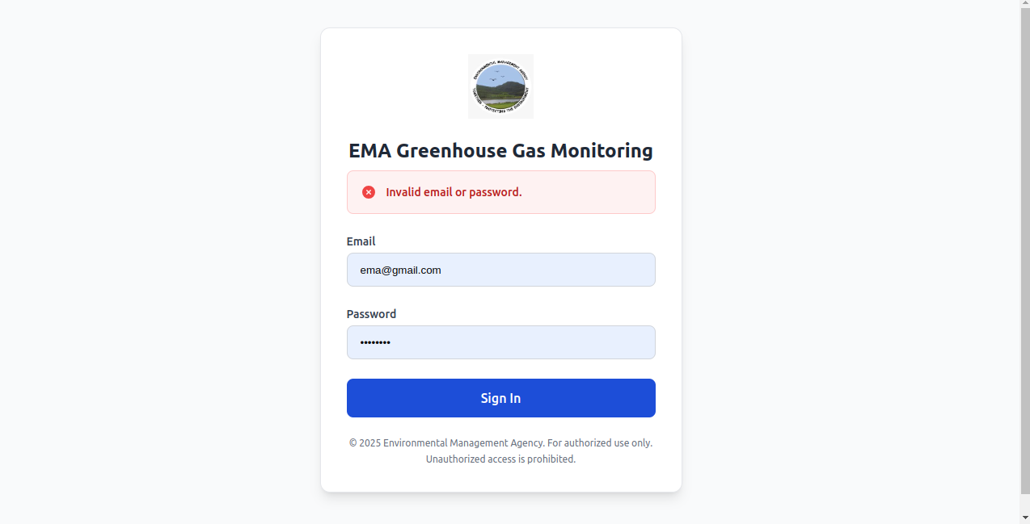  
  Fig 5.3.2 – Login failure message on the web interface



Fig 5.3.2 – Login success message on the web interface

5.4 SECURITY

The nvironmental Management Agency Monitoring System for Greenhouse Gases incorporates multiple security mechanisms to protect both data and system integrity:

* WPA2 Wi-Fi Encryption: All ESP32 devices connect to the network using WPA2 encryption to prevent unauthorized access during wireless communication.

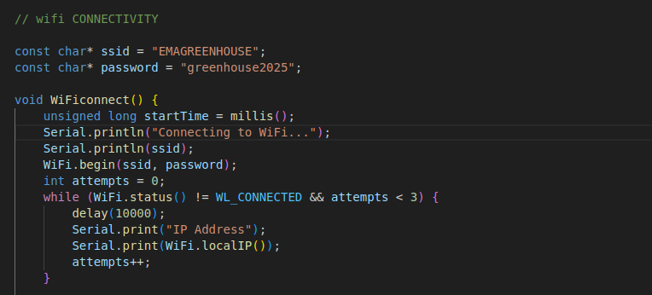

Fig 5.4.1

* MAC Address Verification: Each ESP32 device is assigned a unique MAC address. Before accepting any incoming data, the backend verifies the MAC address against a whitelist to ensure that only authorized devices can send sensor readings.

Fig 5.4.2

* Secure API Authentication: Communication between the ESP32 devices and the web backend is protected through authentication tokens, preventing tampering or spoofing of data.
* User Authentication & Role Management: The web interface implements secure login with email-based authentication and role-based access control, ensuring that only EMA personnel and policy makers can access their respective dashboards.

Fig 5.4.3

* Input Validation & Sanitization: All input data from the ESP32 devices and web forms is validated and sanitized to protect against injection attacks and other malicious input.
* Database Access Restrictions: The backend database is configured with strict access control rules, ensuring that only authorized users or devices can update, view, or delete data.

5.5 INSTALLATION

The system was installed by uploading custom C++ firmware to the ESP32 using PlatformIO, configuring Wi-Fi credentials, and connecting all sensors, LEDs, the LCD display, buzzer, and GSM module. The assembled hardware was mounted in protective enclosures. The web interface, developed in Django, was set up on a local server running on the deployment machine, enabling real-time data monitoring and alert management

5.6 TRAINING

Training was provided to EMA personnel , policy makers and greenhouse owners covering both the hardware indicators and the web interface functionalities:

* Hardware Alert Indicators:
  + Green LED: Wi-Fi connected and system online.
  + Solid Red LED: No internet connection.
  + Blinking Red LED: Dangerous gas levels detected.
  + Orange LED: Warning threshold reached.
  + Buzzer: Immediate high-level danger alert requiring attention.
* Web Dashboard Usage for EMA Personnel:
  + Monitoring real-time sensor data from multiple greenhouses.
  + Viewing active alerts, including the greenhouse location and the specific device triggering the alert.
  + Checking which devices are currently online or offline.
  + Accessing historical logs for emission levels and past incidents.
  + Viewing thresholds and edditing them
* Web Dashboard Usag Policy Maker Tools:
  + Comparing emissions data across multiple regions for environmental assessment.
  + Using the platform’s analytics to monitor trends so that they can make mitigation strategies.

5.7 MAINTENANCE

### 5.7 MAINTENANCE

Maintenance guidelines include:

* Monitoring Wi-Fi signal strength for ESP32 connectivity.
* Periodically updating ESP32 firmware through PlatformIO.
* Reviewing system logs for unauthorized login attempts.
* Cleaning sensors to maintain accuracy and prevent dust interference.
* Regular software updates and bug fixes.
* Create database backups.
* Monitor if sensors working correctly

5.8 SYSTEM EVALUATION

System evaluation showed high performance and responsiveness. The ESP32 devices reliably transmitted data to the Django dashboard with minimal latency. Alerts were triggered instantly when gas levels exceeded thresholds, and the interface displayed readings clearly and accurately.

5.9 FILE CONVERSION AND SYSTEM CHANGEOVER

No significant file conversion was required as the system was designed from the ground up. The changeover plan involves phasing out manual data collection methods and gradually adopting the automated monitoring system to ensure minimal disruption.

5.10 SYSTEM REVIEW

Periodic reviews confirmed that the solution met the requirements for real-time monitoring, alert reliability, and secure user access. Minor issues such as GSM module signal fluctuations were identified for future optimization.

Overall, the system meets the intended goals of providing timely, actionable environmental data to the EMA , policy makers and greenhouse owners.

5.11 RECOMMENDATIONS

* Add battery backup for ESP32 devices to improve uptime during power outages.
* Introduce more environmental sensors for broader data coverage.
* Expand the dashboard with AI-driven predictive analytics for emissions trends.
* Implement SSL/TLS encryption for the Django web server.
* Incorporating mobile applications

5.12 CONCLUSION

The system successfully demonstrates the feasibility of an IoT-based greenhouse gas monitoring platform using ESP32 microcontrollers and Django for real-time visualization. The integration of sensors, alerts, and secure access controls provides a reliable tool for environmental monitoring and decision-making, forming a solid foundation for future scalability.

# References

|  |  |
| --- | --- |
| [1] | A. Kumar and G. Hancke, "Energy Efficient Environment Monitoring System Based on the IEEE 802.15.4 Standard for Low Cost Requirements," *IEEE Sensors Journal,* vol. 14, no. 8, pp. 2557-2566, 2014. |
| [2] | P.Hancke, Anuj Kumar and Gerhard, "Energy Effiecient Environment Monitoring System". |